Solid Geometry - Types of Solids - Uniform Polyhedron - Types of Uniform Polyhedra - Non-Convex Uniform Polyhedra

Definition
# Source: AI Source: Provided by: [Data Path: Persons Table -> ID Column: 1, Name_En Column: Motasem Essam] -> From: [ChatGPT] on [7/25/2026]
A Non-Convex Uniform Polyhedron is a uniform polyhedron whose surface or overall geometric structure is non-convex. It has regular polygonal faces, which may be convex or star-shaped, and a symmetrical arrangement in which every vertex is equivalent under the polyhedron's symmetry group.
Unlike convex uniform polyhedra, non-convex uniform polyhedra may contain:
- Star-shaped polygonal faces.
- Intersecting or crossing faces.
- Indented or re-entrant regions.
- Edges and faces extending through the interior of the solid.
- Self-intersecting geometric structures.
Important: Non-convex does not mean irregular. A non-convex uniform polyhedron can still have regular faces and a highly symmetrical, uniform vertex arrangement.

Geometric Structure
# Source: AI Source: Provided by: [Data Path: Persons Table -> ID Column: 1, Name_En Column: Motasem Essam] -> From: [ChatGPT] on [7/25/2026]
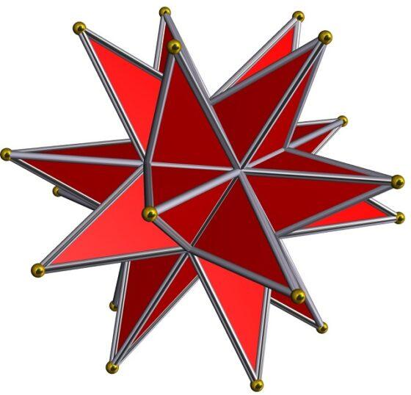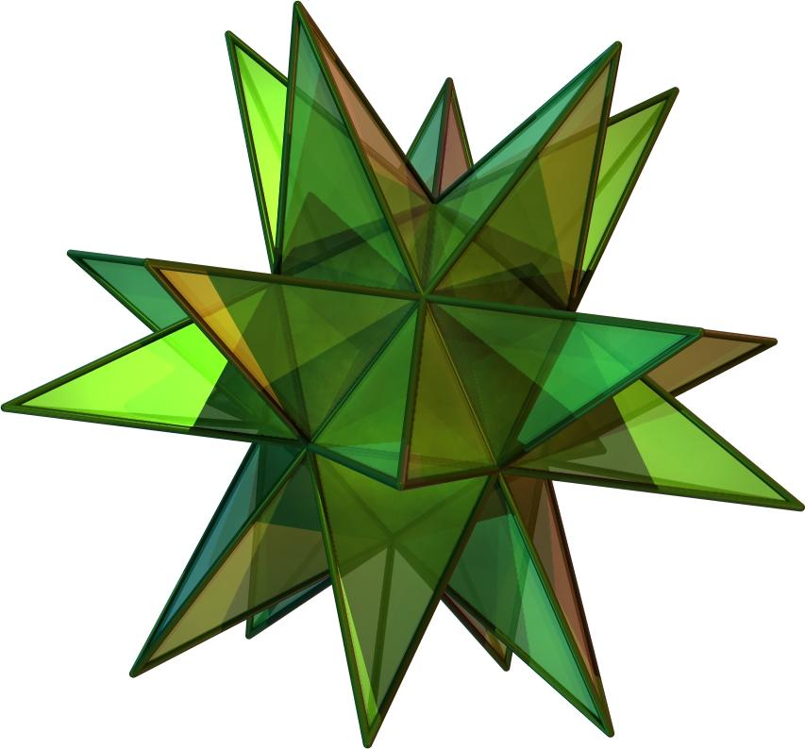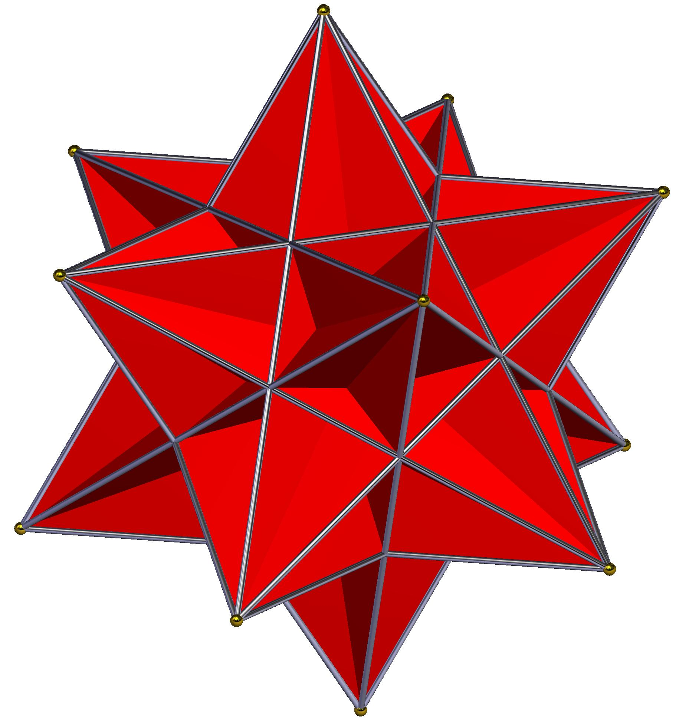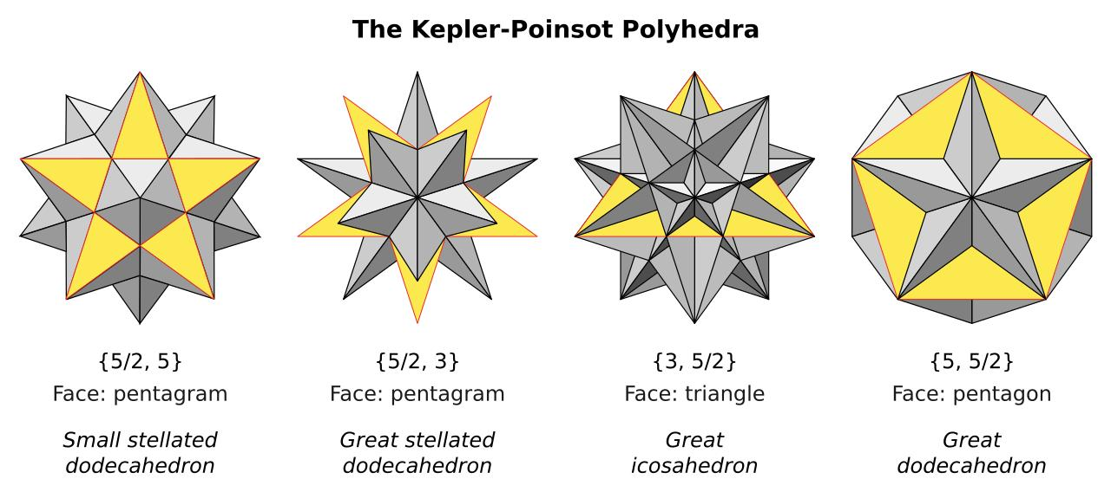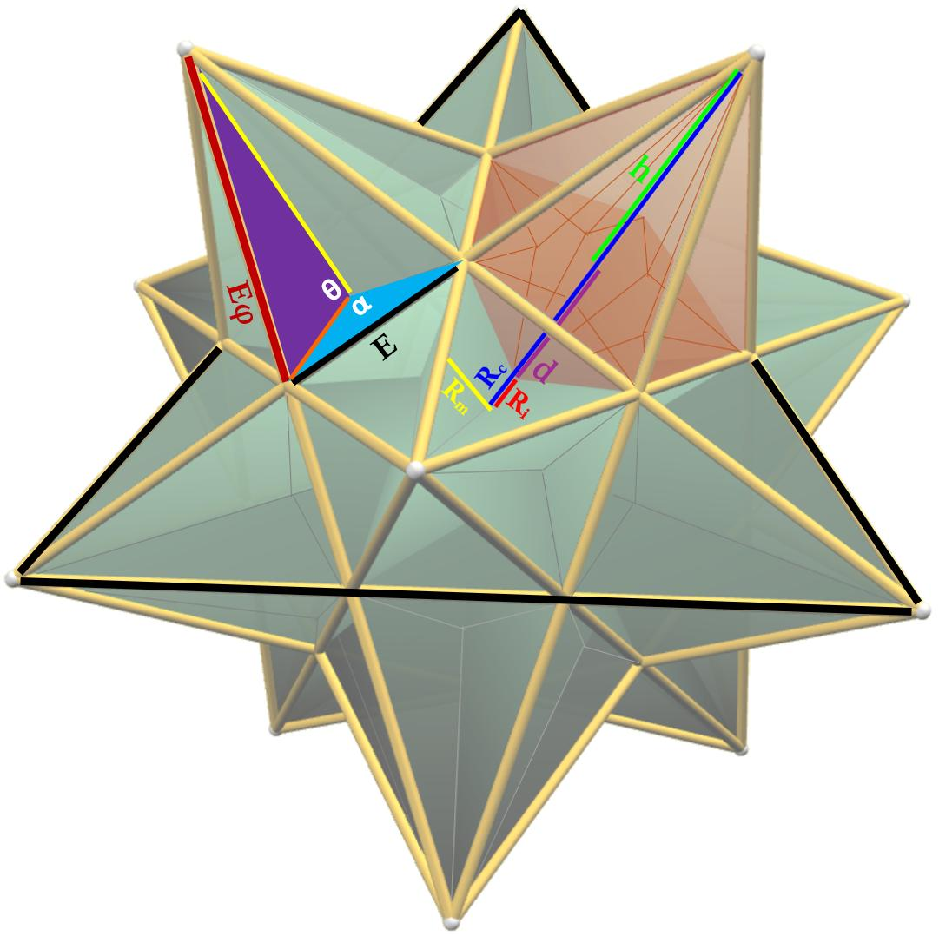

Main Characteristics
# Source: AI Source: Provided by: [Data Path: Persons Table -> ID Column: 1, Name_En Column: Motasem Essam] -> From: [ChatGPT] on [7/25/2026]
- Non-Convex Shape: The polyhedron does not satisfy the convexity condition; some line segments between points of the solid may pass outside its surface.
- Regular Faces: Its faces are regular polygons, including regular star polygons.
- Vertex Transitivity: Every vertex has an equivalent local geometric arrangement under the symmetry group.
- Uniform Edge Structure: Its edges are equivalent under the polyhedron's symmetries.
- High Symmetry: It has rotational and/or reflectional symmetries.
- Face Intersections: Some faces may intersect or pass through other parts of the surface.
- Star Geometry: Some examples use star polygons, such as the pentagram $\{5/2\}$, rather than ordinary convex polygons.

Types of Non-Convex Uniform Polyhedra
# Source: AI Source: Provided by: [Data Path: Persons Table -> ID Column: 1, Name_En Column: Motasem Essam] -> From: [ChatGPT] on [7/25/2026]
Non-convex uniform polyhedra are commonly organized into two major groups.

Kepler–Poinsot Polyhedra
# Source: AI Source: Provided by: [Data Path: Persons Table -> ID Column: 1, Name_En Column: Motasem Essam] -> From: [ChatGPT] on [7/25/2026]
The Kepler–Poinsot Polyhedra are the four classical regular star polyhedra. They are non-convex regular polyhedra whose faces and vertex arrangements are highly symmetrical.
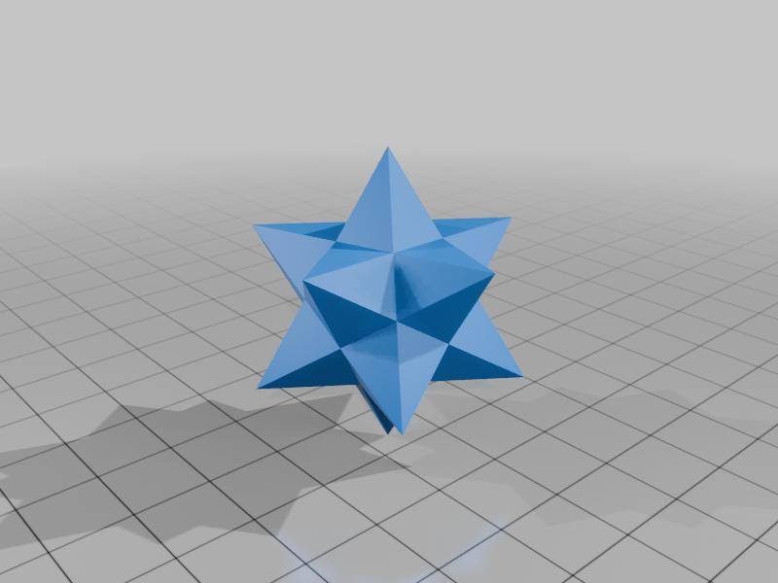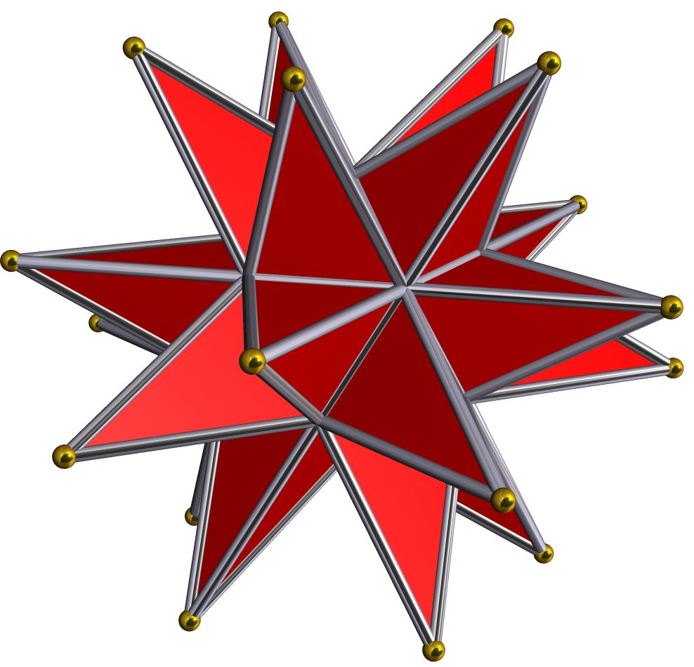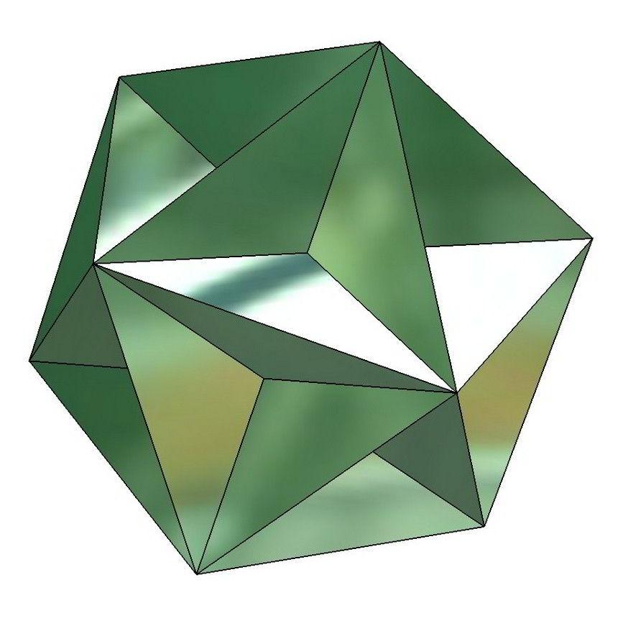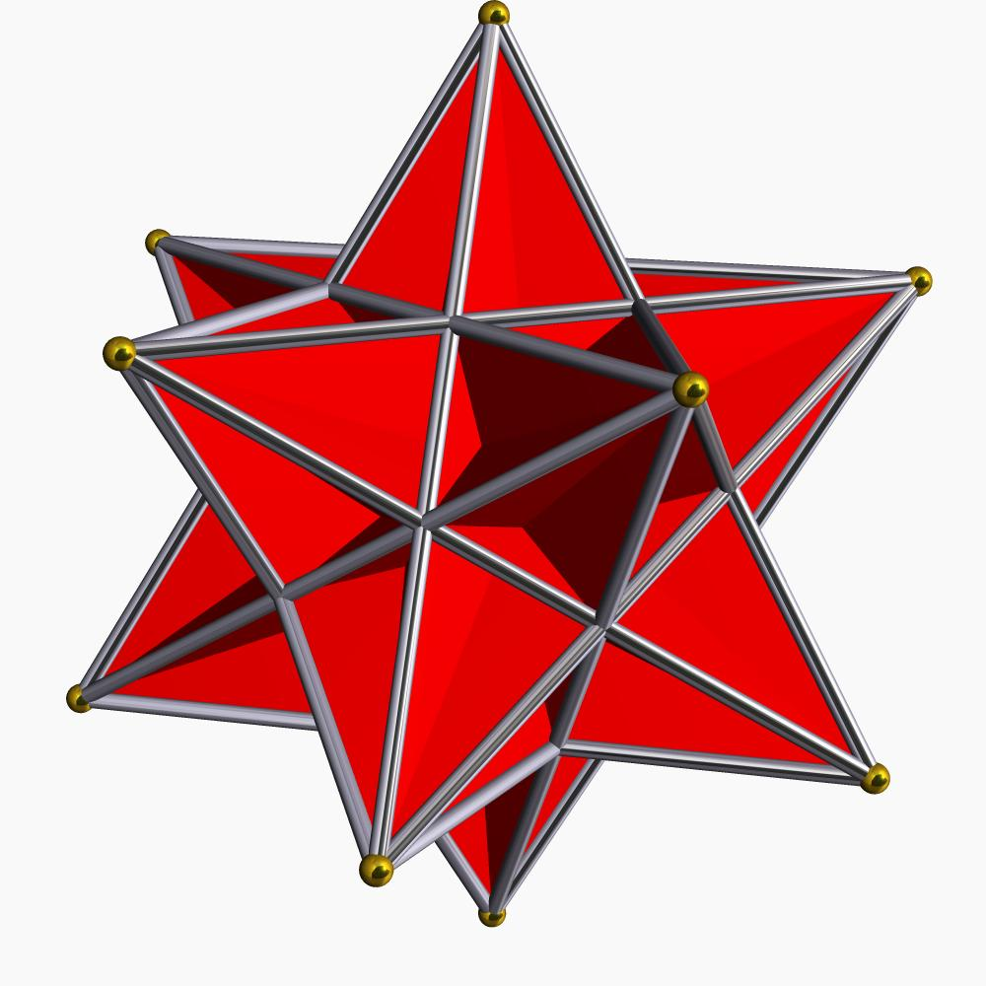
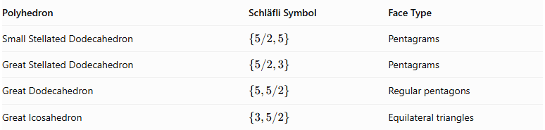
Polyhedron | Schläfli Symbol | Face Type
Small Stellated Dodecahedron | $$\{5/2,5\}$$ | Pentagrams
Great Stellated Dodecahedron | $$\{5/2,3\}$$ | Pentagrams
Great Dodecahedron | $$\{5,5/2\}$$ | Regular pentagons
Great Icosahedron | $$\{3,5/2\}$$ | Equilateral triangles
Key characteristics:
- They are regular star polyhedra.
- Their faces or vertex figures involve star-polygon arrangements.
- They are both face-transitive and vertex-transitive.
- They are a special subgroup of non-convex uniform polyhedra.

Other Non-Convex Uniform Polyhedra
# Source: AI Source: Provided by: [Data Path: Persons Table -> ID Column: 1, Name_En Column: Motasem Essam] -> From: [ChatGPT] on [7/25/2026]
This group includes non-convex uniform polyhedra that are not among the four Kepler–Poinsot regular star polyhedra.
They can have different regular polygonal face types and more than one kind of face or vertex arrangement, while maintaining vertex transitivity.
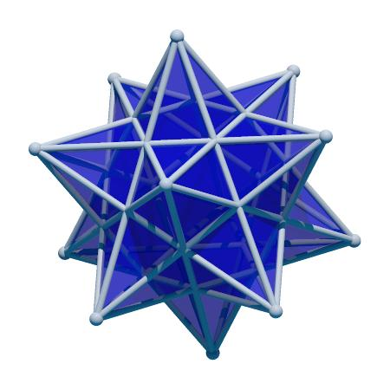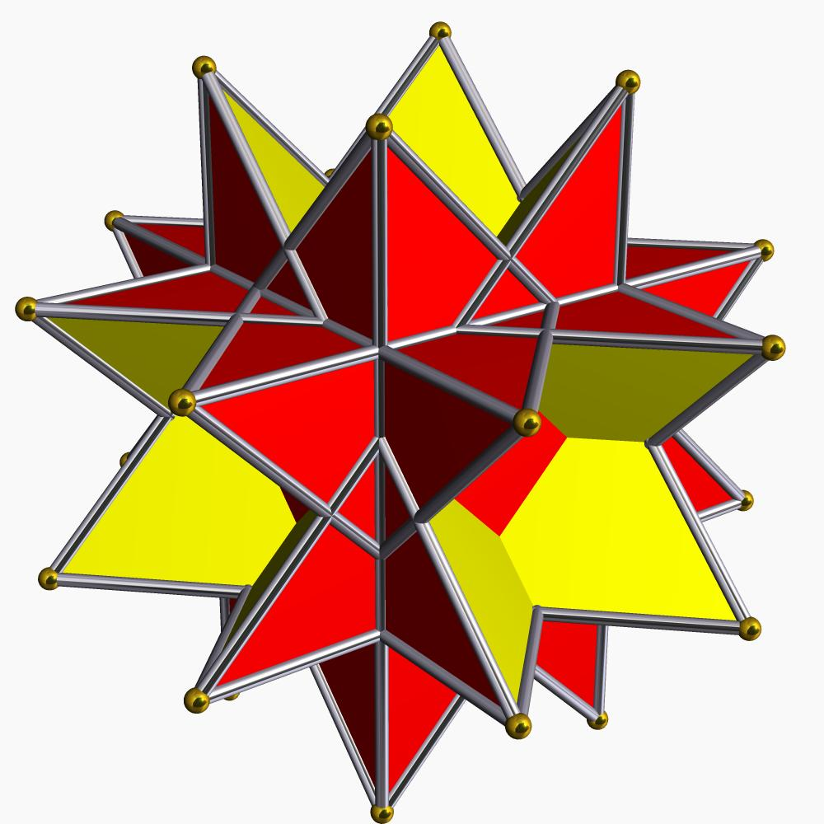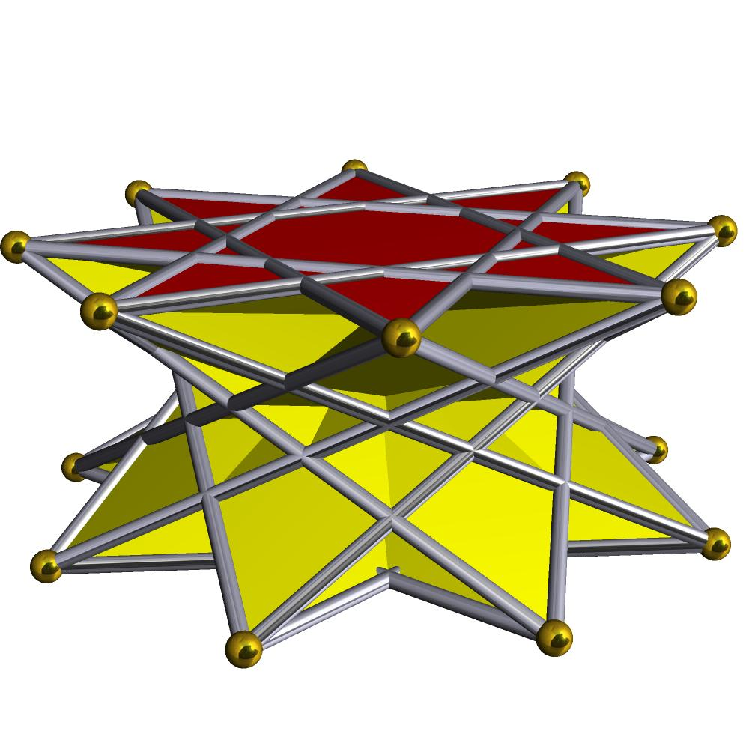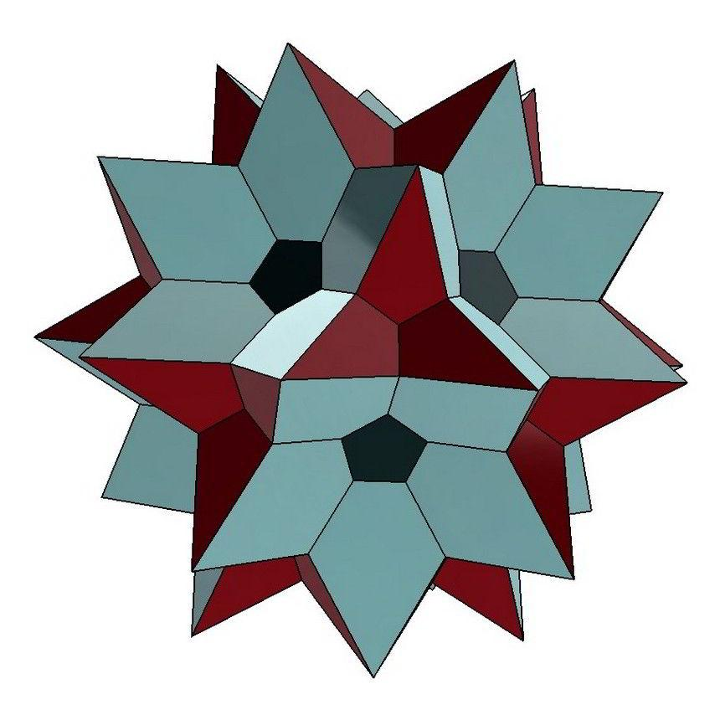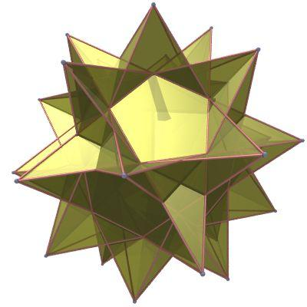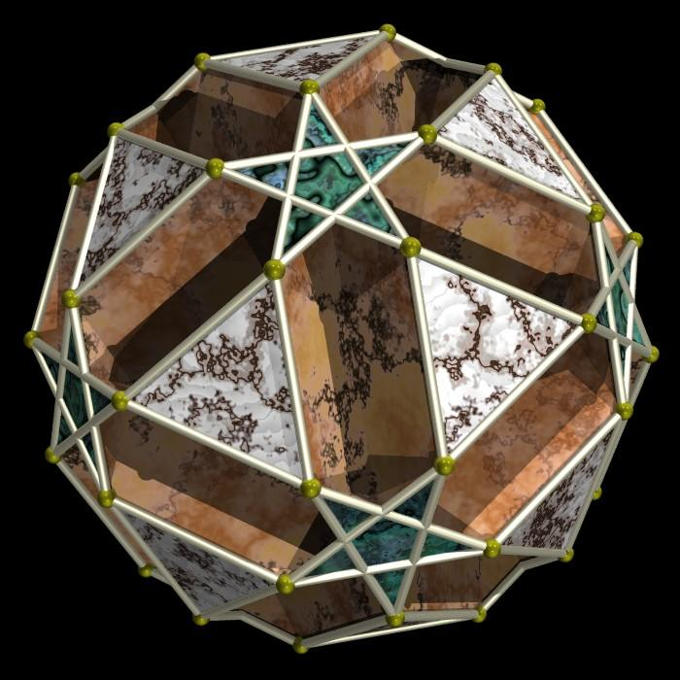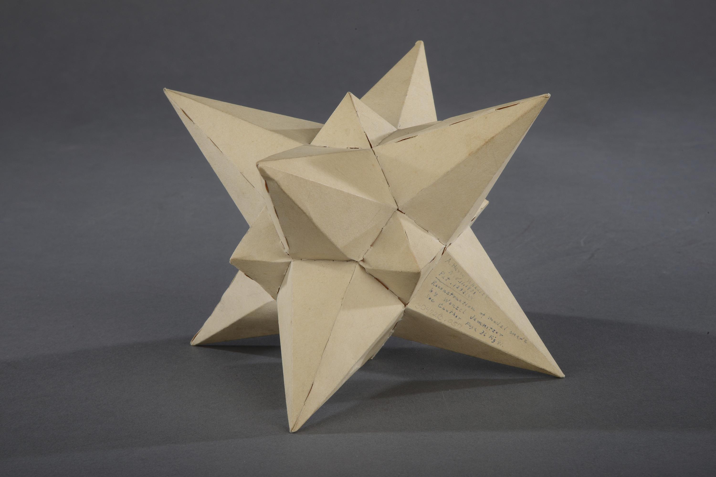
Examples include:
- Great Stellated Truncated Dodecahedron
- Small Stellated Truncated Dodecahedron
- Great Dodecahemicosahedron
- Small Dodecahemicosahedron
- Great Icosicosidodecahedron
- Small Icosicosidodecahedron
These names refer to different uniform star-polyhedron forms; their precise face configurations and classification depend on the particular uniform-polyhedron naming convention.

Mathematical Characteristics
# Source: AI Source: Provided by: [Data Path: Persons Table -> ID Column: 1, Name_En Column: Motasem Essam] -> From: [ChatGPT] on [7/25/2026]
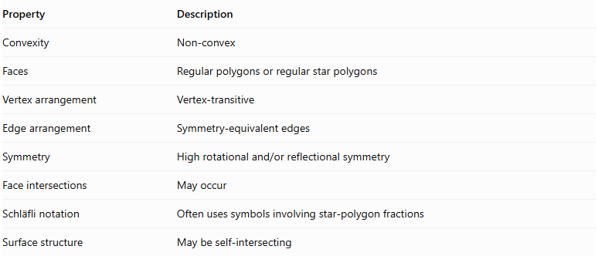
Property | Description
Convexity | Non-convex
Faces | Regular polygons or regular star polygons
Vertex arrangement | Vertex-transitive
Edge arrangement | Symmetry-equivalent edges
Symmetry | $$Highrotationaland/orreflectionalsymmetry$$
Face intersections | May occur
Schläfli notation | Often uses symbols involving star-polygon fractions
Surface structure | May be self-intersecting

Classification by Symmetry
# Source: AI Source: Provided by: [Data Path: Persons Table -> ID Column: 1, Name_En Column: Motasem Essam] -> From: [ChatGPT] on [7/25/2026]
Non-convex uniform polyhedra can also be classified according to their symmetry properties:
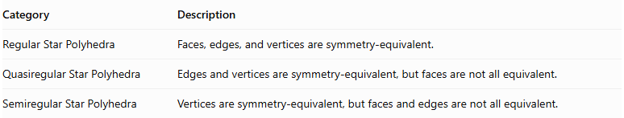
Category | Description
Regular Star Polyhedra | Faces, edges, and vertices are symmetry-equivalent.
Quasiregular Star Polyhedra | Edges and vertices are symmetry-equivalent, but faces are not all equivalent.
Semiregular Star Polyhedra | Vertices are symmetry-equivalent, but faces and edges are not all equivalent.
The four Kepler–Poinsot polyhedra belong to the regular category. The other non-convex uniform polyhedra include quasiregular and semiregular forms.

Important Mathematical Notes

Star Polygon Notation
# Source: AI Source: Provided by: [Data Path: Persons Table -> ID Column: 1, Name_En Column: Motasem Essam] -> From: [ChatGPT] on [7/25/2026]
A regular star polygon is commonly represented by the Schläfli notation:
$$\{p/q\}$$
Where:
- $p$ = number of vertices of the polygon.
- $q$ = number of steps between consecutive vertices when tracing its edges.
For example:
$$\{5/2\}$$
represents a pentagram, or five-pointed star polygon.

Schläfli Symbol of a Regular Star Polyhedron
# Source: AI Source: Provided by: [Data Path: Persons Table -> ID Column: 1, Name_En Column: Motasem Essam] -> From: [ChatGPT] on [7/25/2026]
A regular polyhedron can be represented using:
$$\{p,q\}$$
Where:
- $p$ describes the polygonal face.
- $q$ describes the number of faces meeting at each vertex.
For star polyhedra, either value may involve fractional notation, as in the four Kepler–Poinsot polyhedra.

Euler's Formula
# Source: AI Source: Provided by: [Data Path: Persons Table -> ID Column: 1, Name_En Column: Motasem Essam] -> From: [ChatGPT] on [7/25/2026]
For an ordinary convex polyhedron:
$$V-E+F=2$$
However, this formula cannot automatically be applied to every non-convex uniform polyhedron using its ordinary face, edge, and vertex counts. Self-intersections, star faces, and non-spherical surface structures can change the relevant Euler characteristic. For example, the small stellated dodecahedron and great dodecahedron have Euler characteristic $-6$ under their standard polyhedral counting conventions.

Number of Non-Convex Uniform Polyhedra
# Source: AI Source: Provided by: [Data Path: Persons Table -> ID Column: 1, Name_En Column: Motasem Essam] -> From: [ChatGPT] on [7/25/2026]
Under the classical classification:
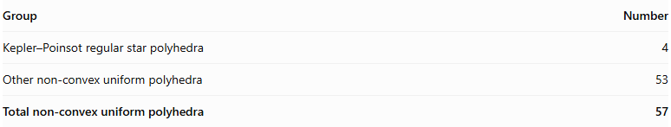
Group | Number
Kepler–Poinsot regular star polyhedra | 4
Other non-convex uniform polyhedra | 53
Total non-convex uniform polyhedra | 57
The 53 additional forms include quasiregular and semiregular star polyhedra. Together with the 18 convex uniform polyhedra, they make up the 75 classical non-prismatic uniform polyhedra.
There are also infinite families of uniform star prisms and star antiprisms. A special additional case, Skilling's figure, is sometimes counted separately when coincident edges are permitted.

Comparison: Convex vs. Non-Convex Uniform Polyhedra
# Source: AI Source: Provided by: [Data Path: Persons Table -> ID Column: 1, Name_En Column: Motasem Essam] -> From: [ChatGPT] on [7/25/2026]
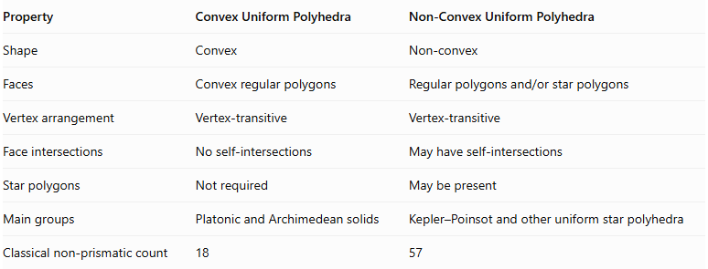
Property | Convex Uniform Polyhedra | Non-Convex Uniform Polyhedra
Shape | Convex | Non-convex
Faces | Convex regular polygons | $$Regularpolygonsand/orstarpolygons$$
Vertex arrangement | Vertex-transitive | Vertex-transitive
Face intersections | No self-intersections | May have self-intersections
Star polygons | Not required | May be present
Main groups | Platonic and Archimedean solids | Kepler–Poinsot and other uniform star polyhedra
Classical non-prismatic count | 18 | 57

Related Geometric Solids
# Source: AI Source: Provided by: [Data Path: Persons Table -> ID Column: 1, Name_En Column: Motasem Essam] -> From: [ChatGPT] on [7/25/2026]
- Kepler–Poinsot Polyhedra – The four regular star polyhedra.
- Uniform Star Polyhedra – Uniform polyhedra with star geometry.
- Star Polygons – Regular self-intersecting polygons.
- Stellated Polyhedra – Polyhedra formed through stellation operations.
- Convex Uniform Polyhedra – Uniform polyhedra with convex geometry.
- Non-Uniform Polyhedra – Polyhedra that do not satisfy the uniformity requirements.

Main Classification
# Source: AI Source: Provided by: [Data Path: Persons Table -> ID Column: 1, Name_En Column: Motasem Essam] -> From: [ChatGPT] on [7/25/2026]
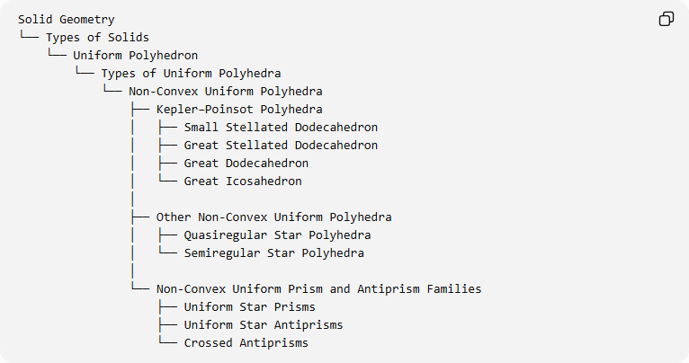
Solid Geometry
└── Types of Solids
└── Uniform Polyhedron
└── Types of Uniform Polyhedra
└── Non-Convex Uniform Polyhedra
├── Kepler–Poinsot Polyhedra
│ ├── Small Stellated Dodecahedron
│ ├── Great Stellated Dodecahedron
│ ├── Great Dodecahedron
│ └── Great Icosahedron
│
├── Other Non-Convex Uniform Polyhedra
│ ├── Quasiregular Star Polyhedra
│ └── Semiregular Star Polyhedra
│
└── Non-Convex Uniform Prism and Antiprism Families
├── Uniform Star Prisms
├── Uniform Star Antiprisms
└── Crossed Antiprisms
Classification note: The last branch represents infinite families, not a finite list of individual solids. The quasiregular and semiregular subdivisions are symmetry-based categories, rather than separate construction methods.

Key Points
# Source: AI Source: Provided by: [Data Path: Persons Table -> ID Column: 1, Name_En Column: Motasem Essam] -> From: [ChatGPT] on [7/25/2026]
- Non-convex uniform polyhedra are symmetrical polyhedra with regular polygonal faces and equivalent vertices.
- Their geometry may include star polygons, intersecting faces, and non-convex vertex arrangements.
- The four Kepler–Poinsot polyhedra are the regular non-convex uniform polyhedra.
- There are 53 additional classical non-convex uniform polyhedra.
- The classical total is 57 non-convex non-prismatic uniform polyhedra.
- Infinite families of star prisms and star antiprisms are classified separately.

Conclusion
# Source: AI Source: Provided by: [Data Path: Persons Table -> ID Column: 1, Name_En Column: Motasem Essam] -> From: [ChatGPT] on [7/25/2026]
Non-Convex Uniform Polyhedra form an important group of uniform solids characterized by regular faces, vertex transitivity, and non-convex or self-intersecting geometry. They include the four Kepler–Poinsot polyhedra, 53 other non-convex uniform polyhedra, and infinite families of star prisms and antiprisms.

